Design & Access Statement
E014090 – Co-op Food Stores, Tean Road, Cheadle, ST10 1LY

This Design and Access Statement has been prepared on behalf of Cashzone in support of an application submitted for:
The installation of an Automated Teller Machine and Non-Illuminated sign.
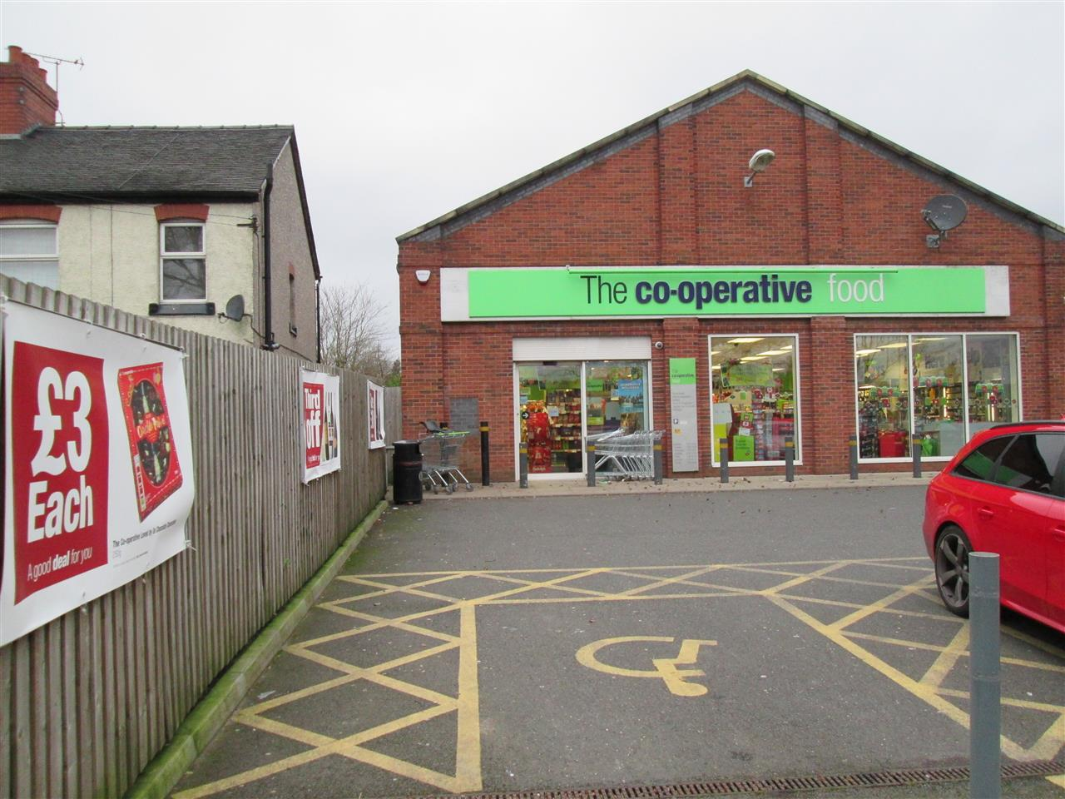

Appearance

We propose to install an ATM through the brickwork to the left of the customer entrance of Co-op Food Store on Tean Road. The ATM will face west on to Tean Road; the shops has no special architectural or historical features and is not within a conservation area.
The immediate area is predominantly residential with some commercial properties in the area such as a public houses, car garages, and there is public park directly opposite the site, however we believe that the installation of an ATM in this location would not be detrimental to them.

Use

The purpose of the installation of this Automated Teller Machine is to provide a 24 hour banking facility for the local community and visitors to the area.

Scale

N/A

Layout

The installation of the ATM has not altered the basic design of the building.
We propose to form an aperture in the existing brick work for the ATM face and have made good with materials matched to the existing.
We consider that this would not be detrimental to the existing street scene.

Amount

This is not a new structure, but the installation of an ATM in an existing shop.

Landscaping

This is not relevant as the installation does not require it.

Design Principals

The ATM is of standard design as located in many areas throughout the UK and is accepted as a necessary facility. There are a number of mandatory standards which apply, relating to the position of the ATM, it’s visibility, ambient lighting, building structure, building security features, ATM anchoring, safe strength.

Designing out Crime

We install and anchor the ATMs in accordance with National Guidelines.

Site approval by the Cash In Transit Company has been obtained. They have considered routes to and from the ATM, ensuring there is protection of their staff and of any staff or customers at the site. Paramount in their review has been the welfare of their staff and the persons they come into contact with.

The area where the ATM has been installed is a well-lit open area in full view of pedestrians aiding natural surveillance.

There are already existing bollards at this site, in front of the ATM location; these were installed for a previous ATM at this location which has since been removed and the aperture bricked up.

Access

The access to the site and other properties has not been affected.

In designing this application, we have taken into account the needs of able and disabled users. The ATM is set at a height that makes it accessible for all users and has space to the front for a wheel chair.
Key 5 has raised markings for blind persons to identify the centre key.

Car parking availability has been considered: There is customer parking available on site.

