REPORT ON A BAT SURVEY AT BROWN LEES

METHODIST CHURCH, BROOK STREET,

BROWN LEES, STOKE-ON-TRENT

July 2013



Ecotrack Limited, 10 Carlton Road, Witton Park, Northwich, Cheshire, CW9 5PR
Tel: 01606 41581 Mobile: 07946 873 865
Email: mikefreeman@ecotrack.wanadoo.co.uk

CONTENTS

- INTRODUCTION

2.0 LEGAL PROTECTION FOR BATS

3.0 BATS IN BUILDINGS

4.0 METHODOLOGY

5.0 TIMING OF THE SURVEY

6.0 LIMITATIONS OF THE SURVEY

7.0 RESULTS

8.0 CONCLUSIONS

9.0 IMPLICATIONS AND RECOMMENDATIONS

- INTRODUCTION

1.1 A bat survey was requested at Brown Lees Methodist Church, Brook Street, Brown Lees, Stoke-on-Trent, Staffs ST8 6PG.

1.2 The Ordnance Survey grid reference is SJ 87550 56214.

1.3 Plans are proposed to demolish the building and erect a number of residential properties on the site.

Site Description

1.4 The site is a brick built Victorian style Methodist Chapel with pitched tile covered roofs of varying height.

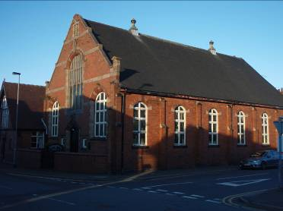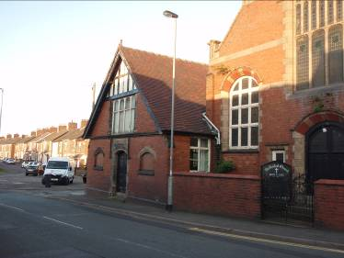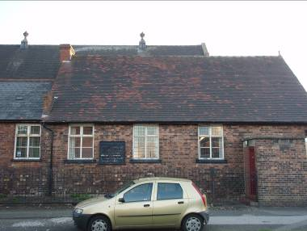

1.5 Most of the ceilings are vaulted, particularly in the higher parts of the church, and no access could be gained into the small roof voids in these areas.

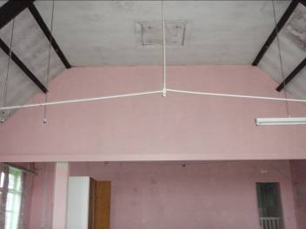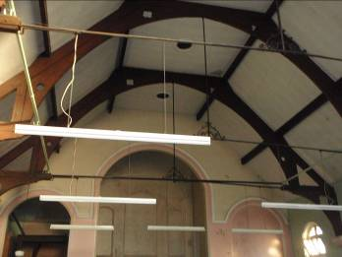

1.6 One roof void, in the lower part of the church could be accessed. The tile roof was lined with a bitumen based traditional roofing felt but there was no loft insulation on the floor.

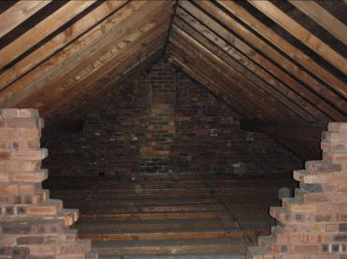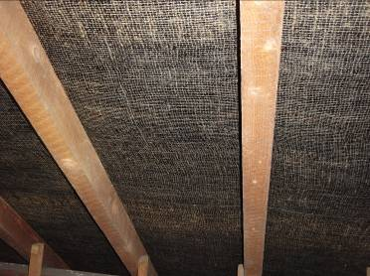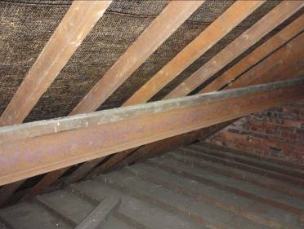

1.7 The church is now redundant and falling into a state of disrepair. However, the roof tiles and ridges appear to be in good order with few gaps.

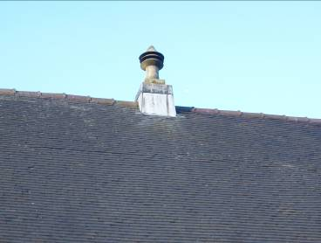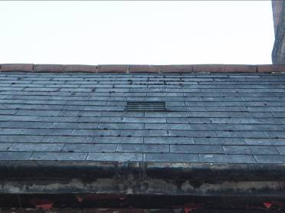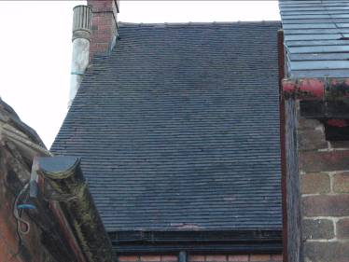

1.8 The building is situated in the centre of Brown Lees on the junction of Brook Street and Brown Lees Road.

1.9 It is generally built up around the site with mainly residential properties.

Aims of the survey

1.10 To ascertain if bats use, or have previously used, the Chapel for roosting.

1.11 To recommend any further actions necessary as a result of the survey findings.

Surveyor details

1.12 The survey was conducted by Mike Freeman. He is a professional wildlife consultant specialising in bats, badgers and birds. He has been a licensed bat worker since 1984 and a licensed bat worker trainer since 1989 (Licence No. 20123594). He has been chairman of the Cheshire Bat Group since its formation in 1986 and is a voluntary Bat Warden for Natural England. He is an Associate member of the Chartered Institute of Ecology and Environmental Management (ACIEEM).

1.13 Assistance was given by Ged Ryan. He is a long established key member of Cheshire Bat Group and is a licensed bat worker and licensed bat worker trainer (Natural England Licence No. CLs02649).

2.0 LEGAL PROTECTION FOR BATS

2.1 All UK bats and their roosts are protected by law which gives strong legal protection to all bat species and their roosts. For all countries in the UK the legal protection maybe summarised as follows:

You will be committing a criminal offence if you:

1. Deliberately* capture, injure or kill a bat
2. Intentionally or recklessly disturb a bat in its roost or deliberately disturb a
group of bats
3. Damage or destroy a bat roosting place (even if bats are not occupying the
roost at the time)
4. Possess or advertise/sell/exchange a bat (dead or alive) or any part of a
bat

5. Intentionally or recklessly obstruct access to a bat roost even if bats are
not present at the time

*In a court, ‘deliberately’ will probably be interpreted as someone who, although not intending to capture/injure or kill a bat, performed the relevant action, being sufficiently informed and aware of the consequence his/her action will most likely have).

Defences include:

1. Tending/caring for a bat solely for the purpose of restoring it to health and
subsequent release
2. Mercy killing where there is no reasonable hope of recovery (provided that
person did not cause the injury in the first place – in which case the illegal
act has already taken place).

Penalties on conviction – the maximum fine is £5,000 per incident or per bat (some roosts contain several hundred bats), up to six months in prison, and forfeiture of items used to commit the offence, e.g. vehicles, plant, machinery.

NB Whilst the protection afforded to bats is virtually the same in all UK countries please refer to the specific legislation for England and Wales, Scotland and Northern Ireland for the precise wording – the above is a brief summary only.

Licensing Procedures

Licences to permit illegal activities relating to bats and their roost sites can be issued for specific purposes by the relevant licensing authorities in each country. These are sometimes called ‘derogation licences’ or ‘European Protected Species’ licences. It is an offence not to comply with the terms and conditions of a derogation licence. If you carry out work affecting bats or roosts without a licence, you will be breaking the law.

In the case of development works 3 tests must all be satisfied before the relevant licensing authority can issue a licence:

1. A licence MAY be granted ‘to preserve public health or public safety or
other imperative reasons of overriding public interest including those of a
social or economic nature and beneficial consequences of primary
importance for the environment’.
2. A licence may NOT be granted UNLESS the licensing authority is satisfied
‘that there is no satisfactory alternative’.
3. A licence CANNOT BE ISSUED unless the licensing authority is satisfied
that the action proposed ‘will not be detrimental to the maintenance of the population of the species concerned at a favourable conservation status in their natural range’.

2.2 The following people need to take particular note of the legislation:
- Property owners/householders who have a bat roost in their property
- Woodland owners/managers, and owners of individual trees
- Arboriculturalists and foresters
- Pest controllers
- Planning officers
- Building surveyors
- Architects
- Property developers
- Demolition companies
- Builders
- Roofers
- Ecological consultants

3.0 BATS IN BUILDINGS

3.1 Buildings provide a choice of safe, dry places made from materials like timbers, bricks, stone, tiles and slates.

3.2 Buildings present a whole range of potential roost sites for bats e.g.: -
In walls:

- Behind external hanging tiles or weatherboarding
- In cavity spaces
- At top of solid walls

In eaves:

- Above soffit, or behind fascia and barge boarding

In roofs:

- In tunnel under ridge tiles
- Between underfelt and tiles or slates
- In roof space along ridge beam and at timber joints, at gable end or around chimneybreast.

3.3 The most obvious use of buildings by bats is between May and August, when the pregnant females gather in maternity roosts to give birth and raise their young.

3.4 Females and young often remain in one site all summer or move about using several roosts.

3.5 Most summer colonies will have dispersed by the autumn, though brown long-eared bats often appear early in the year (early April) and leave later (October or later). These bats occasionally use the roost throughout the entire year.

3.6 Buildings may also be used as temporary or “transitional roosts” by small numbers of adult and immature bats of both sexes, particularly in spring and autumn.

3.7 Many outbuildings are attractive to bats for temporary night-time roosts or as sheltered feeding perches. The latter are indicated by the presence of a lot of insect remains, particularly of moths or large beetles and some droppings.

3.8 Cool, undisturbed, humid places are important as hibernation sites. Most species will tuck themselves into small crevices e.g. between bricks/stonework, and can easily pass the winter there unnoticed.

3.9 Bats are usually concealed in crevices, behind roofing felt, in cavity walls, behind soffits and barge boards, in old timber joints or under ridge tiles and are only occasionally seen out in the open in lofts. Consequently, the key identification feature is the presence of droppings. Sometimes droppings may be found on the outside of buildings e.g. on windows, walls or windowsills. On other occasion’s droppings found in loft spaces beneath ridge-boards and around chimneys or gable ends is also typical of bats. Hibernating bats leave little or no field signs.

3.10 Bats are sometimes drawn to open water tanks in lofts in search of a drink. They fall into the tank, can’t get out and eventually drown. Dead bats are often found in these ‘open’ tanks in roof spaces where bats habituate.

3.11 Another clue to the presence of bats is a characteristic odour. A polished or clean surface near a place where light enters may also indicate habitual usage by bats. Sometimes bats can be heard “chittering” but this is usually in warm summer weather or when they are about to leave the roost to forage at dusk.

3.12 The species most commonly occurring in buildings (usually modern houses in summer) are the two pipistrelle species (Pipistrellus pipistrellus, Pipistrellus pygmaeus). These highly gregarious small bats use buildings for breeding during the summer and, in general, the bats disperse during the autumn. They often roost behind soffits, in cavity walls or behind external cladding. In such cases droppings are often found on external surfaces below the roost entrance/exit. The most likely place to find droppings in the roof void are at the gable end wall and along the eaves. In some cases, the bats may roost beneath ridge tiles, on top of the ridge beam or under insulation close to the eaves. Pipistrelles are frequently found overwintering deep in the cracks, crevices and cavities of usually uninhabited buildings (e.g. barns) and in such cases they leave little or no field signs.

3.13 The brown long-eared bat (Plecotus auritus) is the second most common species in Britain but is the one most likely to be encountered in roof voids and may occasionally be seen clinging on to timbers near the apex of the roof. Like the pipistrelle, highest numbers may be seen on hot days between June and September when breeding colonies may be present. During the autumn and in cool weather, bats remain concealed in crevices or hollow walls but may appear on mild days or if disturbed. Brown long-eared bats tend to fly around in the open roof void and hang from the ridge during the night, so droppings are usually found scattered over the floor or concentrated in piles beneath favoured roosting areas, typically beneath the ridge beam. In hipped roofs, piles of droppings may also be found in the junction between two hips.

3.14 A number of other species - serotine (Eptesicus serotinus), greater horseshoe bat (Rhinolophus ferrumequinum) and lesser horseshoe (Rhinolophus hipposideros) are dependent on roofs but are not found locally in the area, though there has been the occasional record of serotine in the North West.

3.15 Whiskered (Myotis mystacinus), Brandt’s (Myotis brandtii), Natterer’s (Myotis nattereri) and Daubenton’s (Myotis daubentonii) bats may be present in the area and may be found in roofs but they are not particularly common in such sites. Roosting position is variable but they will be found in the same sorts of places as other species.

3.16 There are six different types of bat roost (A M HUTSON 1993)

- Spring gathering roosts
- Maternity roosts
- Mating roosts
- Night roosts and feeding roosts
- Prehibernal roosts
- Hibernation roosts

Bats regularly move from site to site even within the above categories.

4.0 METHODOLOGY

4.1 The church was searched, where accessible, during the day for evidence of bat usage as detailed in Section 3.0 above.

4.2 Ladders, a powerful hand lamp and fibre optic endoscope were used as aids.

4.3 Additionally, two surveyors conducted an evening emergence survey looking for bats leaving the building.

4.4 Each surveyor used a tuneable, portable, heterodyne bat detector and binoculars as aids to locating and identifying any flying or emerging bats. A night vision scope was also available to use if necessary.

5.0 TIMING OF THE SURVEY

5.1 The initial daytime survey was conducted on the 4th June 2013.

5.2 The evening emergence survey was conducted on the 21st June 2013.

5.3 The weather during the evening survey was fine, clear and calm. The following temperatures were noted during the survey.

TIME (HRS) | TEMP (° C)
21.00 | 18.0
22.15 | 15.1
22.30 | 14.3
23.00 | 13.9

6.0 LIMITATIONS OF THE SURVEY

6.1 Some areas of the roof voids could not be checked internally due to the height of hatches (where present). However, these voids were likely to be small due to the vaulted ceilings beneath.

6.2 The evening survey was a ‘one-off’ single survey and can only give a snap-shot of bat activity at that time of year under those weather conditions.

6.3 However, it is considered that, due to the lack of evidence and activity found, sufficient survey effort has been carried out on this site to provide confidence to the conclusions drawn.

7.0 RESULTS

7.1 No evidence of bat roosting was found anywhere during either the daytime or evening surveys.

7.2 The roof void that could be entered provided no evidence to suggest that bats roost, or have ever roosted, in there.

7.3 During the evening survey no bats were seen to emerge from the building by either of the surveyors.

7.4 However, there were a small number of bats picked up on the bat detector as follows.

TIME | SPECIES | COMMENTS
22.10 | Common pipistrelle | Flying at front of building on Brook Street
22.21 | Common pipistrelle | Flying along Brown Lees Road
22.25 | Common pipistrelle | Flying along Brown Lees Road
22.31 | Common pipistrelle | Flying at rear of Chapel by houses

7.5 No other bats were recorded during the evening survey. It should be noted that not all recordings are necessarily from different bats. It could be one single bat flying by the observers a number of times.

7.6 Just to re-iterate at no time was any of the above bats seen to emerge from the Chapel building during the evening.

Swifts

7.7 It was noted that a number of swifts were using the Chapel eaves for roosting/nesting.

7.8 They were seen entering the roof area under the eaves mainly on the elevation of the Chapel along Brown Lees Road.

8.0 CONCLUSIONS

8.1 No evidence of bat roosting was found at the Chapel and the building has limited potential for such activity, particularly with roof void dwelling bats like brown long eared.

8.2 Swifts (Apus apus) do use the Chapel for roosting or nesting during the summer months.

9.0 IMPLICATIONS AND RECOMMENDATIONS

9.1 As no evidence of bat roosting was found during the survey a Natural England licence is not currently required before the building is demolished.

9.2 However, bats can, and do, change their roost sites regularly. If a roost is subsequently found the situation is likely to change and a licence required.

9.3 In the unlikely event that bats are found during building operations work must cease immediately in that area, the bats left alone and a bat consultant contacted for advice.

9.4 Site workers should not handle bats on health and safety grounds. If this is absolutely unavoidable (unlikely) then thick leather gloves should be worn to avoid being bitten.

Birds

9.5 If the chapel buildings are to be demolished in the period March – August inclusive then due care should be given to avoid disturbing nesting birds. Many bird species can nest in the buildings on site and at least the main chapel building is known to have nesting swifts. Swifts are summer visitors and habitually use the same nest site annually (some pairs have been known to use the same nest site for over 15 years.)

9.6 All species of wild bird, their nests and eggs are protected under the Wildlife and Countryside Act (WCA) 1981 (as amended) and, amongst other things, it is an offence to, with certain exceptions, intentionally or recklessly:

- Kill, injure or take any wild bird
- Take, damage or destroy the nest of any wild bird while it is in use or being built
- Take or destroy the egg of any wild bird

9.7 Additionally Schedule 1 Part 1 of the WCA lists a number of bird species that receive special attention. These birds are protected by special penalties AT ALL TIMES and it is an offence to disturb any wild bird listed on Schedule 1 whilst it is nest building, or at a nest containing eggs or young, or disturb the dependant young of such a bird.

Avoidance of nesting birds

9.8 It appears that birds (particularly summer migrants like swifts) are nesting later this year due to the very poor spring.
9.9 Swifts are normally on eggs (incubation period 19-20 days) anytime from May to July. These birds have a fledging period of around 42 (37-56) days which means they may not leave the nest until the end of August on average. They normally lay around 2-3 eggs (rarely 1-4) and they are single brooded.

9.10 In view of this, demolition should be timed to be carried out after all the birds have fledged. This is likely to be September. Demolition is also best conducted in the Sept/Oct period or late March/April to avoid the most sensitive periods for bats namely maternity and hibernation respectively.

9.11 If demolition is to take place before this then surveys will be required to show that nesting has been completed by ALL birds and the fledglings have left the nest or that the buildings to be demolished have not been used for nesting. There is no evidence of bird nesting apart from the main chapel building.

