WP1: 9M MEDIUM: AT GRID REF: 427322,551163
WP1: 9M MEDIUM: AT GRID REF: 427322,551163
WP1: 9M MEDIUM: AT GRID REF: 427322,551163
WP1: 9M MEDIUM: AT GRID REF: 427322,551163
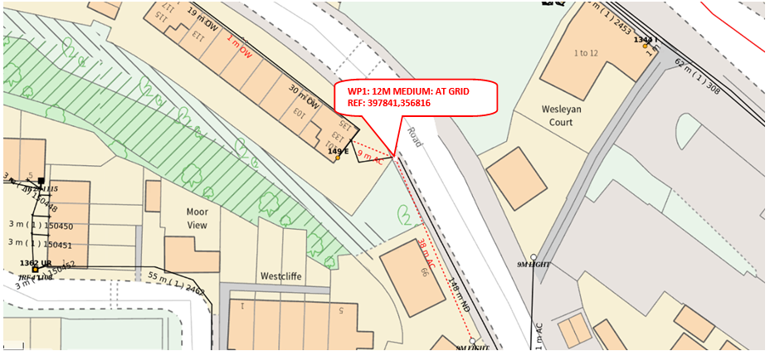
PROVIDE 1 X 12M MEDIUM POLE AT WP1
WP1: 9M MEDIUM: AT GRID REF: 427322,551163

