WORK LOCATION:
WP1: 9M MEDIUM: OFF DP923 REAR 4 THE WALKS, LEEK, ST13 8BY @GRID REF:397894,356191
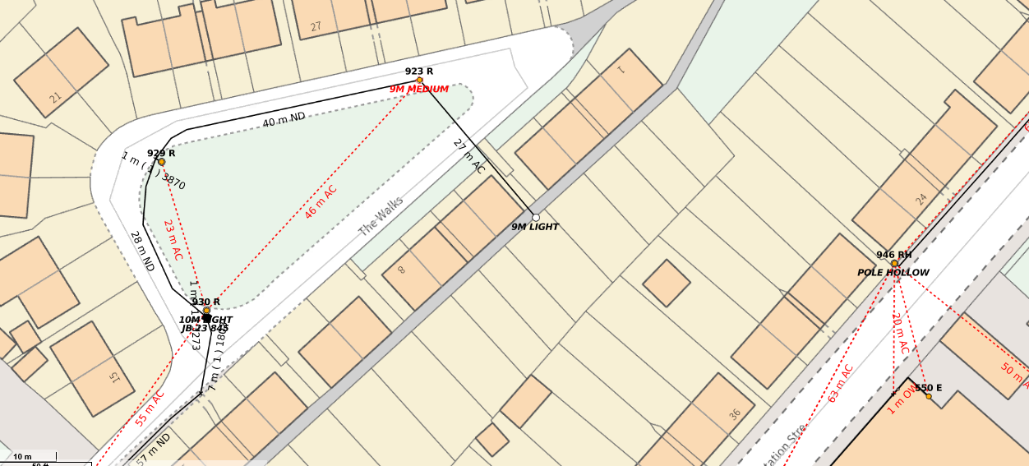
WP1: 9M MEDIUM AT GRID REF: 397894,356191
WP1: 9M MEDIUM: AT GRID REF: 427322,551163
WP1: 9M MEDIUM: AT GRID REF: 427322,551163
WP1: 9M MEDIUM: AT GRID REF: 427322,551163
WP1: 9M MEDIUM: AT GRID REF: 427322,551163
WP1: 9M MEDIUM: AT GRID REF: 427322,551163

