Environment Agency responses

1. Clarify the following modelling aspects (for more information see attached modelling spreadsheet alongside this response) including:
- a) Model approach – no files were supplied for sensitivity testing so we have been unable to check this, nothing in the reporting around quantifying uncertainty.
Comments added to the 2022 report.

- b) 1D model build – the updated reporting does not include dimensions of the proposed channel so it is not possible to say whether this is appropriately represented in the model.
The proposed channel width, bed levels and top of bank levels are shown in External Levels drawing ref. 21047-100, included in Appendix A of the Flood Risk Assessment.

- c) 1D boundary conditions – it looks like the inflow boundary was a ReFH boundary previously and now is an FEH boundary. There is nothing in the reporting to say whether this has been changed so we are unsure whether this is correct / has been changed.
To confirm, no changes have been made to the inflow boundaries in the model. Baseline v_016, the 2018 Baseline DAT file (screenshot below) shows a FEH Boundary within the model.
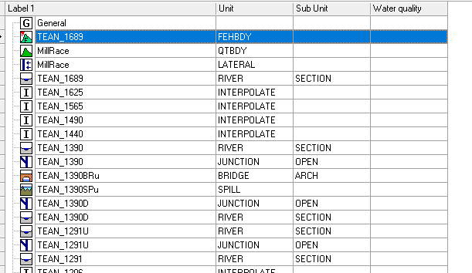

- d) 1D structures – as with the proposed channel, dimensions for the proposed bridge have not been provided other than the soffit level.
Dimensions of the proposed bridge are provided and included within Appendix A of the Flood Risk Assessment.

- e) Model stability – there is no comment on warnings in reporting.
Comments added to report.

- f) Audit trail – there is no model log or details of file versions supplied.
- Model log will be included.

2. Confirm why Figure 4-2 in the current FRA baseline flood risk is different from Figure 4-2 in the FRA submitted for the Outline Planning Permission (SMD/2018/0234). Please confirm if this is due to the use of LiDAR in the current FRA. If not, please explain why.
Yes, this is due to updated ground level data used in the latest model.

3. Confirm whether the ditches along the A552 are still required or not. Regarding the blockage scenario, the flood level of the new watercourse on the northern boundary of the site is the same as the proposed finished floor levels. Please confirm what mitigation has now been proposed (ditch and bund?) against this residual flood risk.
The updated flood risk modelling study demonstrates that the ditches along the A552 are still required during a residual 1000-year overtopping scenario and 100-year plus 31% climate change blockage scenario. The ditch and bund have therefore been included.

4. Confirm the flood risk to the 5 properties at the south-east of the site because:

- a) Although the flood risk may be reduced as the proposed ‘external levels plan’, ref: 21047-100, rev D suggests ground levels will be higher than the flood levels as shown on Figure 3-4 in Appendix C, Figure 4 suggests that this area of the site remains at flood risk. As such further explanation of the flood risk in this area is needed.
The latest model results do not show flooding within the site.

- b) Modelled flood levels in Appendix C appear to be at the same level as the proposed finished floor levels in this part of the site and the 1 in 1000 year flood level is higher than proposed finished floor levels.
The latest model results do not show any flooding within the site. However, all buildings are set above the 100-year climate change and 1,000-year in-channel peak water level. For buildings closest to the watercourse, a 600mm freeboard above the 100-year plus climate change level has also be applied.

5. Include a table of the modelled flood levels for the River Tean, or a paragraph on flood risk to the proposed development layout from this source. It is also not clear how far the River Tean modelled flood levels may back up the proposed channel and influence flood levels within the brook.
The River Tean water levels are significantly lower than the proposed development ground levels (e.g. 1,000-year peak water where the Broadgate Hall brook discharges into the River Tean is 109m AOD). This is significantly lower than peak water levels in the Broadgate Hall Brook. Therefore flood risk to the site is considered to be from the Broadgate Hall Brook and not from backing up of the River Tean.

6. Include an updated drawing of B15296-225 to show the currently proposed channel and easements. Please also mark the floodplain extents (1 in 100yr plus 30% climate change) and 3m easement on Drawing number 21047-100, rev D as contour lines.
Drawing included in Appendix A of the Flood Risk Assessment.

