REPORT REF; - HE 07 / 5832

Soil Sampling and Analyses

at

M Boydon & Sons

The Garage
Ashbourne Road
Winkhill
Nr Leek
Staffordshire
ST13 7PP

for

The Winter Partnership

24 Rottingdean Place
Brighton
East Sussex
BN2 7FS

Study Period; - July 2007

ISSUE STATUS | HE 07 / 5832
ISSUE REV1 | CHECKED: S J LATHAM | APPROVED: T GROWCOTT
ISSUED | 23.07.2007

CONTENTS

1 INTRODUCTION

2 ANALYTICAL RESULTS

3 SITE REMEDIATION AND ENVIRONMENTAL ISSUES

APPENDIX 1 LABORATORY TEST RESULTS

THE WINTER PARTNERSHIP
24 ROTTINGDEAN ROAD
BRIGHTON
EAST SUSSEX
BN2 7FS

23rd July 2007

FAO: Mr S Cooper - Director

REPORT REF; - HE 07/5832

SOIL SAMPLING AND ANALYSIS AT
THE M BOYDON & SONS SITE, WINKHILL, Nr LEEK, STAFFS

1 INTRODUCTION

This study was undertaken under instruction of The Winter Partnership in regard to the proposed development of a garage premises. The M Boydon & Sons site is located approximately 6 miles south - east from Leek.

The location within the Winkhill Area is delineated as National Grid Ref SK 061 514. The site is no longer operational as a coach operator and associated garage and is subject to development into offices by the Winter Partnership.

The main environmental concerns relative to this location are the immediate proximity of the River Hamps and the potential pollutant infiltration from the sites 3 off fuel tanks and associated maintenance automotive products including glycol based anti-freeze, oils and lubricants, asbestos containing materials (sourced from brake pad materials), detergents (used in vehicle cleaning) and miscellaneous materials including fillers, sealers, paints and thinners.

The site’s main storage tanks were used for hydrocarbon-based fuels including petrol and diesel. The tanks were designed to contain spills and specifically prevent the potential for migration into underlying soils and groundwaters. There is one recorded unauthorised release during M Boydon’s occupancy, to site drainage and to the locality.

When activities at the premises ended, all 3 tanks were emptied as a precautionary measure.

Contamination potential exists from the operation of the site’s activities during operation and post closure. The potential for the loss of hydrocarbon based fuels. Lubricants, greases and vehicle maintenance consumables appears to be primarily associated with the site 3 storage tanks.

5 off soil samples were obtained by personnel and submitted to an accredited third party contractor, Eurofins, for analysis.

The samples were designated as follows; -

Halcyon Reference Number | Site sampling Descriptor | Contract Laboratory Reference | Contractor | UKAS Accreditation Reference
HE 07/ 5832/01 | Winkhill A | 02299722 | Eurofins | 0680
HE 07/ 5832/02 | Winkhill B | 02299722 | Eurofins | 0680
HE 07/ 5832/03 | Winkhill C | 02299722 | Eurofins | 0680
HE 07/ 5832/04 | Winkhill D | 02299722 | Eurofins | 0680
HE 07/ 5832/05 | Winkhill E | 02299722 | Eurofins | 0680

2 ANALYTICAL RESULTS

Analyses were undertaken via an accredited third party contractor and the analytical sheets for each sample are included in Appendix 1.

2.1 Lead

All 5 samples show relatively high lead content. This would indicate a high naturally occurring concentration across the site.

2.2 All Remaining Analytes

All remaining analytes define “benchmark” conditions for the site and its future development.

3 SITE REMEDIATION AND ENVIRONMENTAL ISSUES

A copy of this report should be submitted to Local Authority in support of any site development.

Tim Growcott B Sc (Hons) MRSC C Chem C Sci MIMF
Senior Partner

WINT5832 CONT LAND REP

APPENDIX 1

ANALTYICAL CERTIFICATES
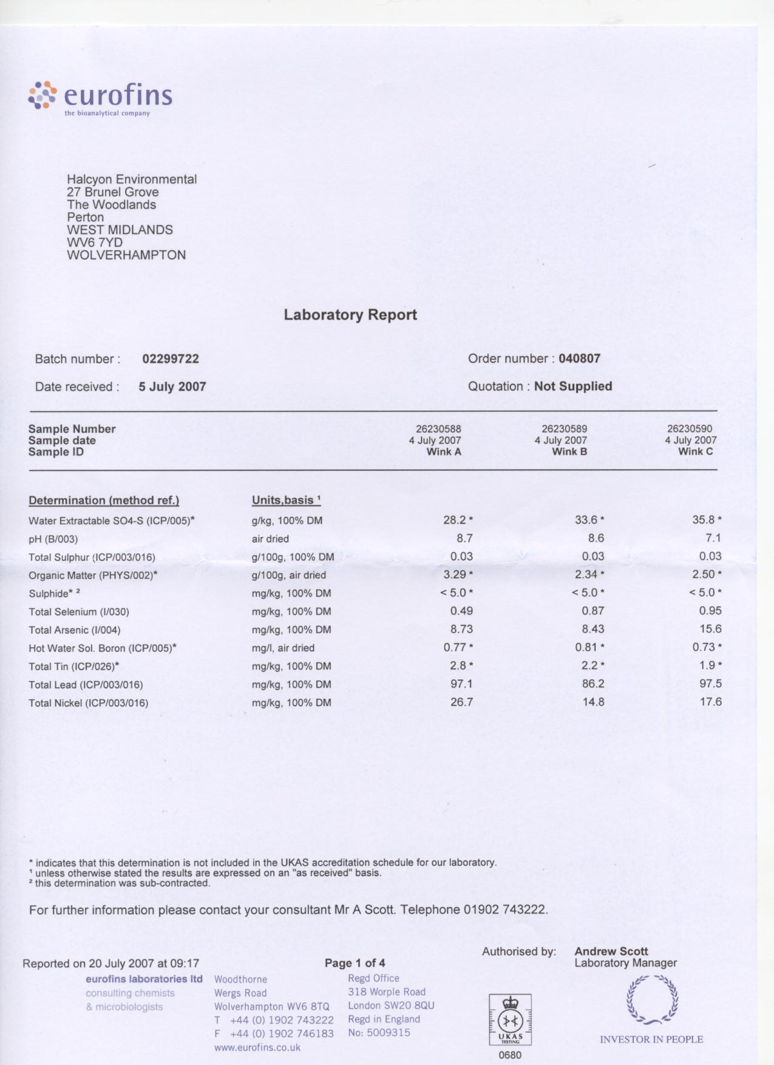
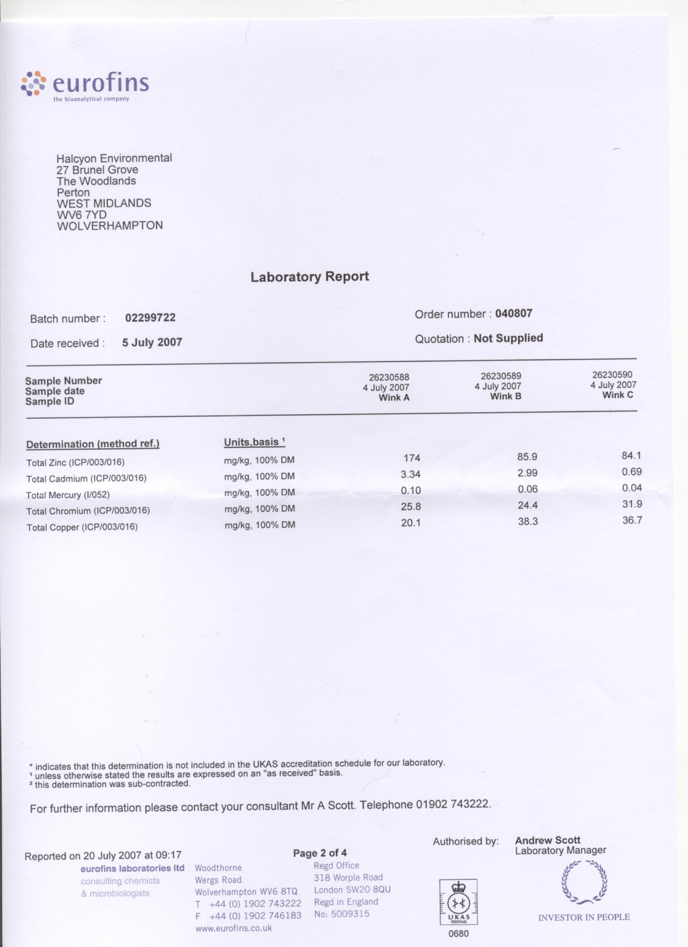
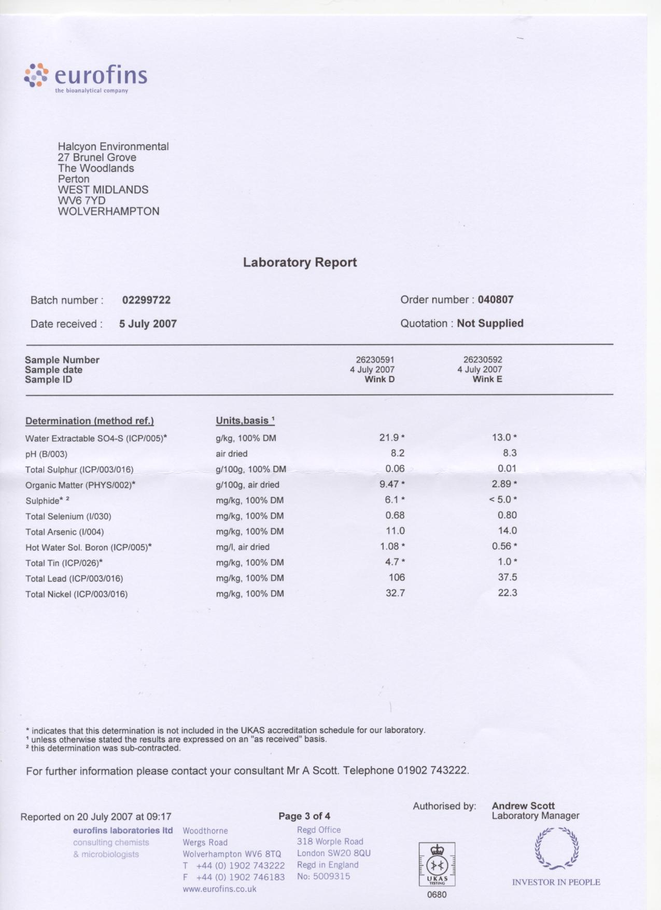
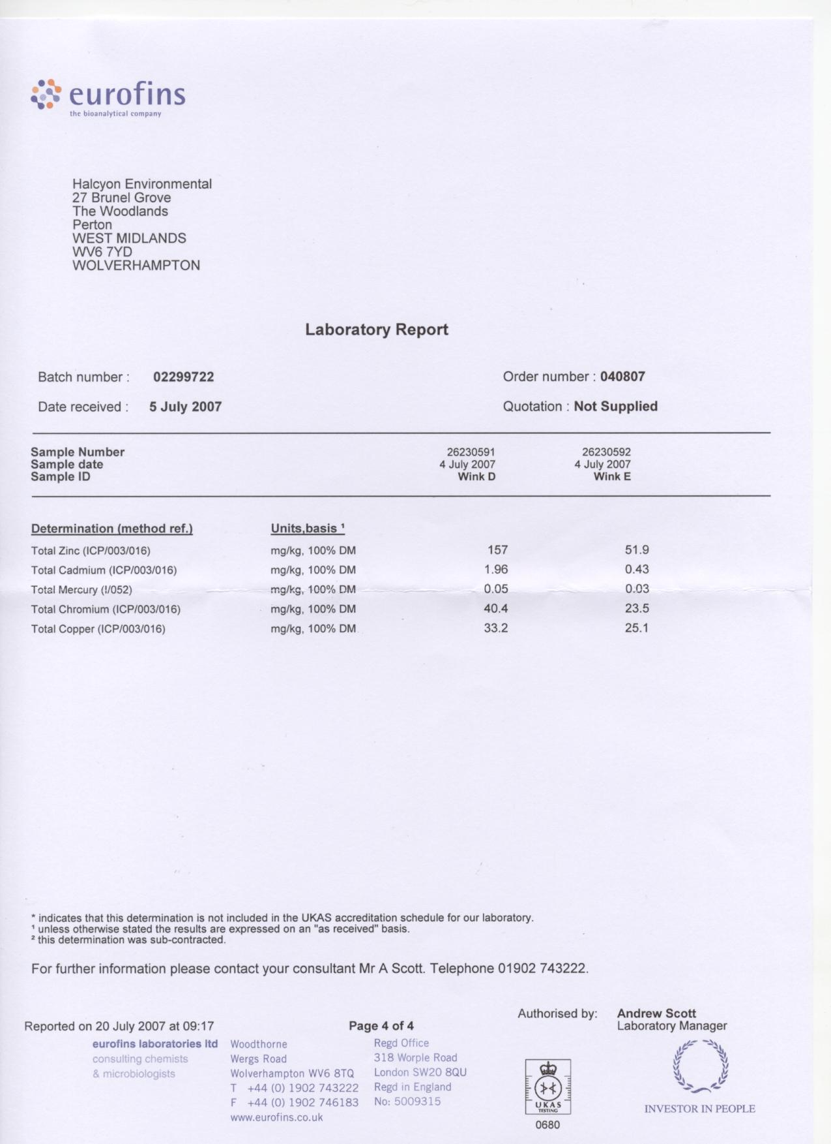
The following organic components were determined; -

Halcyon Reference Number | Site sampling Descriptor | Total Organics  mg/kg | PAHs  ug/kg | Phenols (mono)  mg/kg
HE 07/ 5832/01 | Winkhill A | < 10 | < 20 | < 1
HE 07/ 5832/02 | Winkhill B | < 10 | < 20 | < 1
HE 07/ 5832/03 | Winkhill C | < 10 | < 20 | < 1
HE 07/ 5832/04 | Winkhill D | < 10 | < 20 | < 1
HE 07/ 5832/05 | Winkhill E | < 10 | < 20 | < 1

